Anurag Rachcha SQL 3 (1-6) :

Answer 1) Using AdventureWorks - List all the employees show name and department

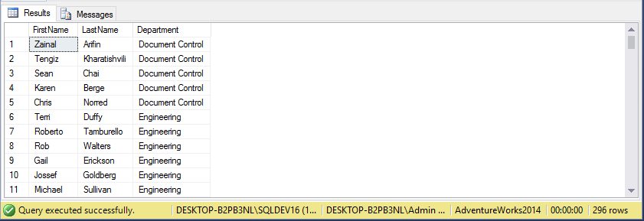

Answer 2) Using AdventureWorks - Show the employees and their current and prior departments

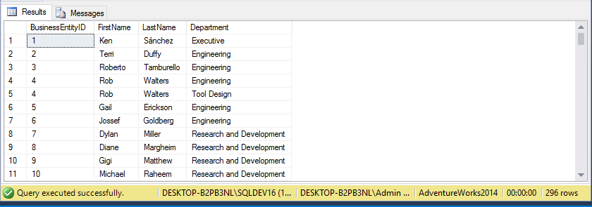

Answer 3) Using AdventureWorks - Break apart the employee login id so that you have the domain (before the /) in one column and the login id (after the /) in two columns

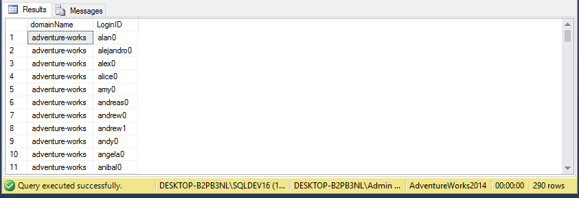

Answer 4) Using AdventureWorks - Build a new column in a copy of the employee table that is the employee email address in the form login_id@domain.com, populate the column

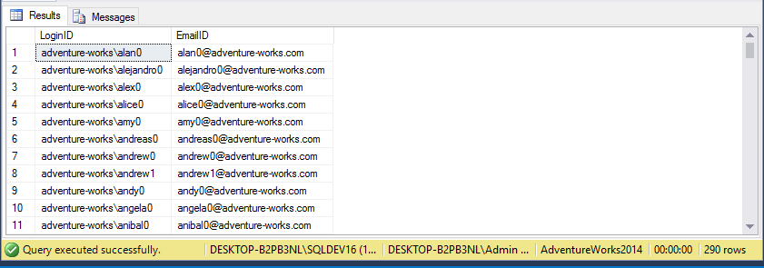

Answer 5) Using AdventureWorks - Calculate the age of an employee in years - Does it work if the birthday hasn't happened yet if not fix it

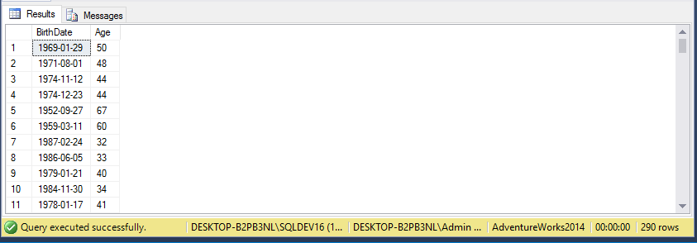

Answer 6) Using Pubs - List a titles prior year sales, define the current year as the max year in the sales (use a subquery).

